Activity 1.3: Drawing a square
Use the skills you have just learnt to draw a square.
This is what you should see on the stage when your program finishes running:
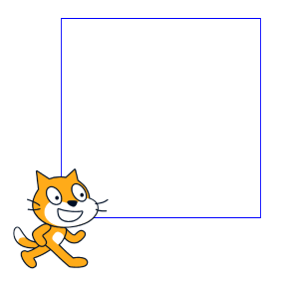
Don’t forget to screenshot your blocks and paste the screenshot into your evidence document.

Extension activities

Can you improve your program so that the cat draws the following shapes?
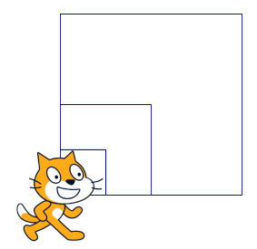

Extension activity 1

Can you improve your program so that the cat draws the following shapes?

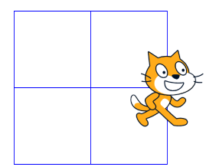

Extension activity 2

Remember to screenshot your blocks and paste the screenshot into your evidence document.

